Little SPARK: Simple Play Adaptations to Reference for Kids

Pouring Cup
Description: | Image:
The Pouring Cup is a switch-enabled measuring cup mounted on a flexible gooseneck stand that provides opportunities for anyone with physical disabilities to participate in everyday activities.  4 AA batteries required.  User’s Manual | 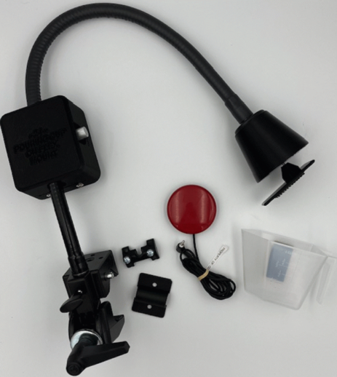

Who Might Benefit?
Those who have require physical assistance to engage in daily living, academic, and creative activities and benefit from support that enables full participation across learning and play environments.

Why Use?
Provides an opportunity to actively participate in elements of cooking, science, art, and academic activities, fostering engagement and inclusion across diverse learning experiences.
Instructions for Use: | Adaptation Ideas:
Environmental Considerations  - Use on a flat surface where it can be securely clamped.  Positioning  - Use in seated position or on the floor with a surface to clamp the gooseneck onto.  Basic Play/Use  - See User’s Manual.  Extended Play/Use  - Use for cooking, science, art, math, gardening, or literacy activities.  Play/Use with Others  - Easily use with two individuals, one to load the cup, the other to activate the switch. | Stabilize It  - Use Velcro or Dycem/shelf liner to keep items in place on the table.  Add Sensory Cues  - Add textures, colors, or picture symbols to the switches.  Communication Support  - Communication boards to support the specific activity.  Alternative Uses  - Use different switches until finding the right fit for the individual/activity.

Words to Encourage Play/Use
Go  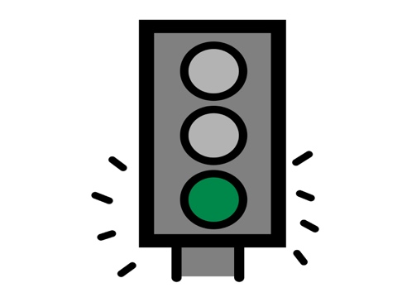 | Stop   | Pour 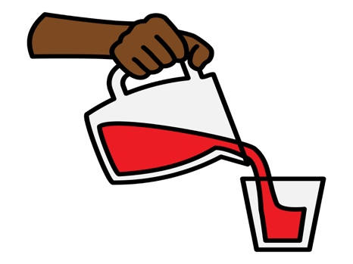
Done | More 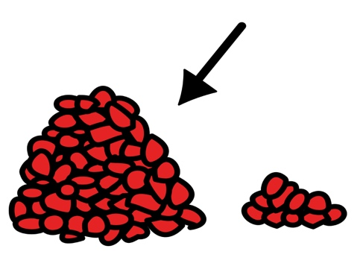 | In  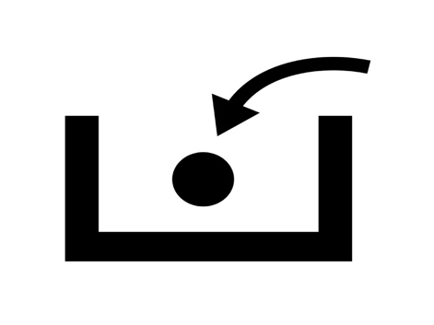
My Turn | Your Turn   | Help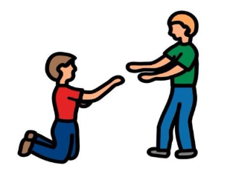
*”Adaptations” adapted from: Haugen’s Modes for Adapting Toys based on materials from the "Let's Play" Project at the University of Buffalo
PCS is a trademark of Tobii Dynavox, LLC. All rights reserved. Used with permission.

